LAB: Module 1 – Hello Android

In this lab, you will install and configure the Android development environment and create a simple “Hello World” application.

1. If you are using Windows, download and install the Java JRE (or Java SDK which includes Java JRE) from the following location:  
   <http://www.oracle.com/technetwork/java/javase/downloads/index.html>

Tip: You can skip this step if you are running Mac OS X or have already installed Java JRE/JDK previously on your machine.

1. Download the ADT bundle from the following location:  
   <http://developer.android.com/sdk/index.html>
2. Extract the downloaded package and move it to the desired location.
3. Run Eclipse.  
   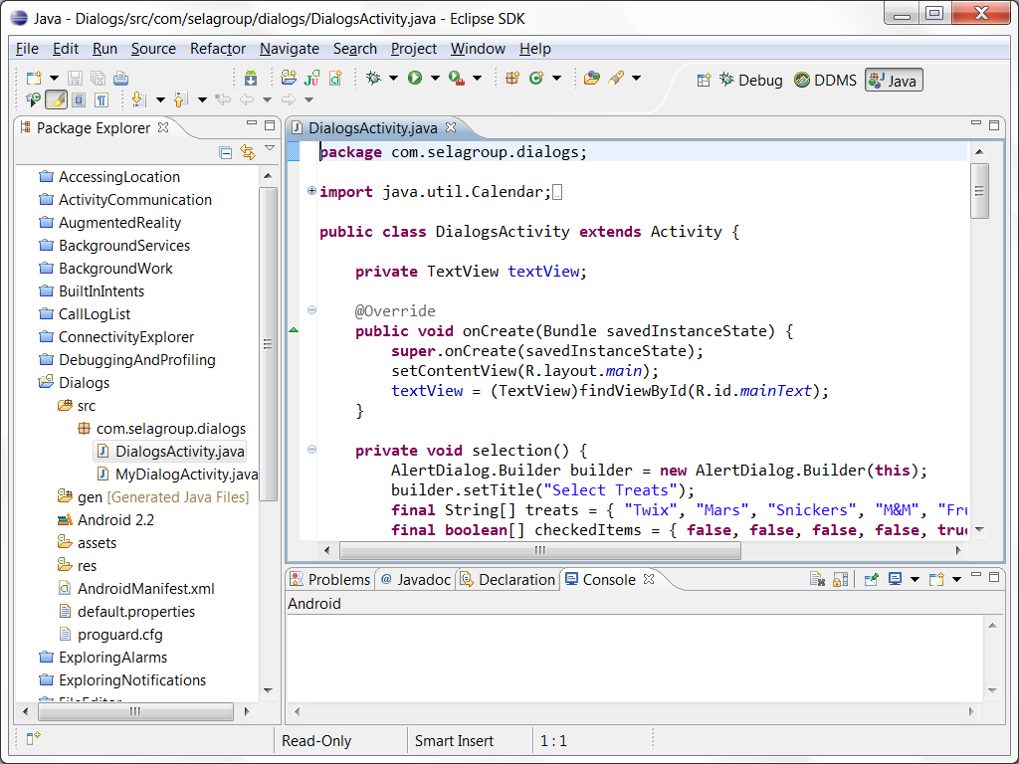
4. Create a new Virtual Device (AVD):
   1. Select Window 🡪 Android Virtual Device Manager, and switch to the **Device Definitions** tab.
   2. Select one of the devices (e.g. Nexus S) and click **Create AVD**.
   3. Fill the device properties and click **OK**.
   4. When the new device is created it will appear in the list of available AVDs:  
      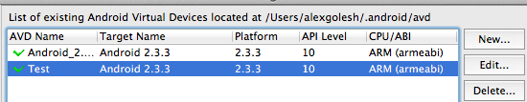
   5. Select the device and click **Start** button, verify suggested launch options and click **Launch** to see the emulator: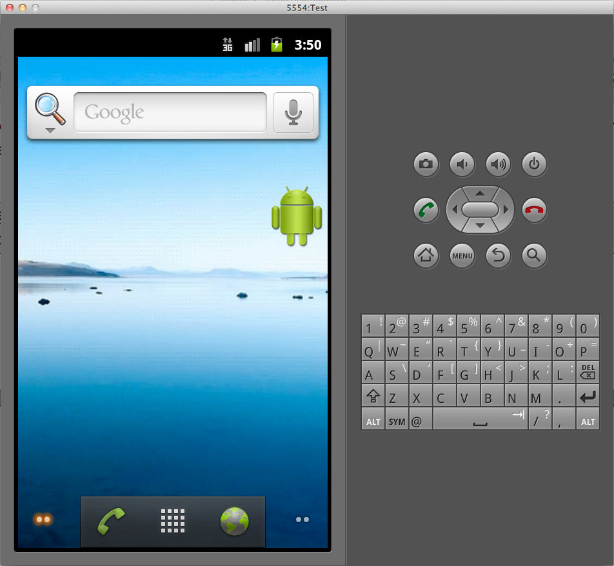

Note: The Android emulator takes some time to start up (up to several minutes on a slow machine). It is recommended to keep it running between debugging sessions instead of closing and relaunching it every time.

1. Create a new Eclipse project by using the File 🡪 New 🡪 Android Application Project menu item. Name the project **HelloWorld** and use the **com.selagroup.helloworld** package.
2. Explore the created project:
   1. The **src** folder contains the **com.selagroup.helloworld** package with one default file named **HelloWorldActivity.java**. This class holds the basic implementation of the activity. We will learn about activities in the next module.
   2. The **gen** folder contains an additional part of the **com.selagroup.helloworld** package with one auto-generated file named **R.java**. This file provides references to the resources used in the project and is generated automatically by the Android development tools. Please refrain from modifying this file manually.
   3. The **res** folder contains application icons for various resolutions (**drawable…** folders) and the **strings.xml** file (under **res/values**) with string resources defined in the project. Android tools provide two ways of editing this file – a wizard-like editor:  
      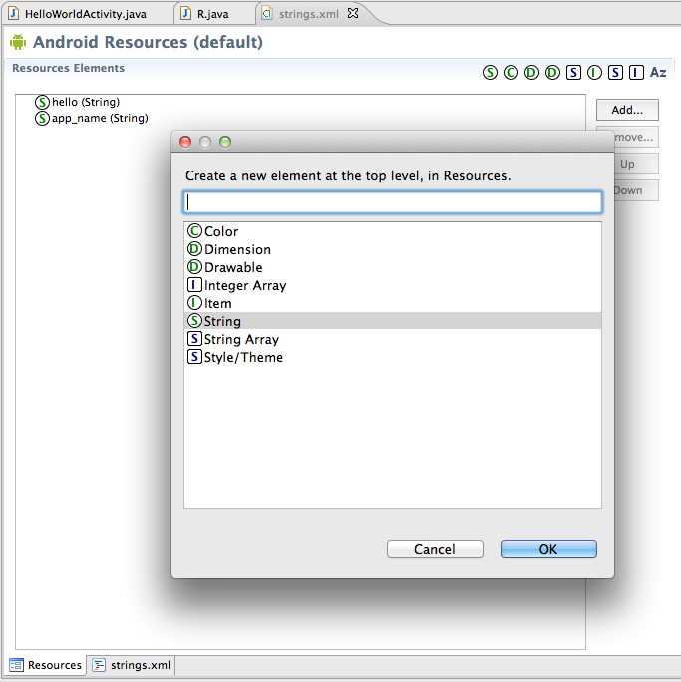  
      …and a simple XML text editor:  
      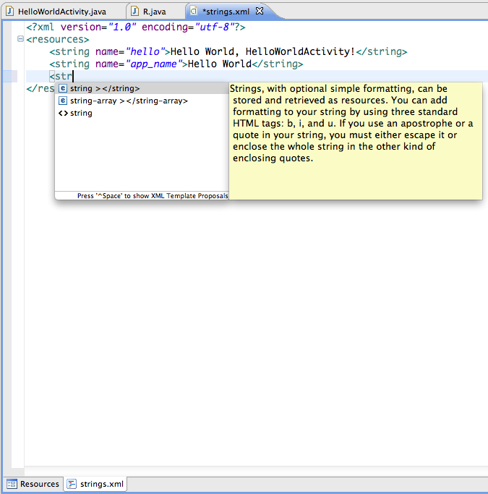
   4. The **res/layout** folder contains the default application’s view definition in the main.xml file. Similarly to resources, the Android development tools provide a rich graphical interface with drag-and-drop capabilities to edit the UI, as well as an XML editor.  
      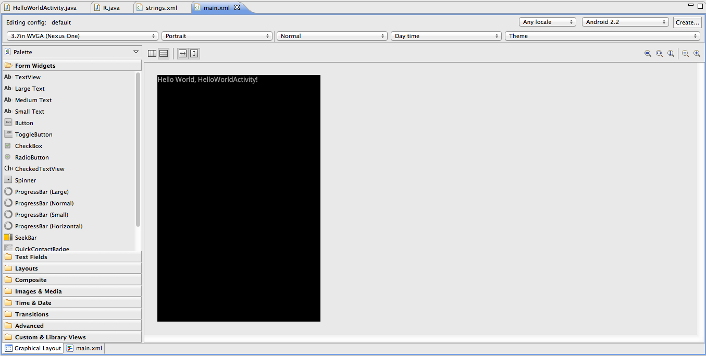
3. Experiment with the UI editor and resources editor to produce the following UI:  
   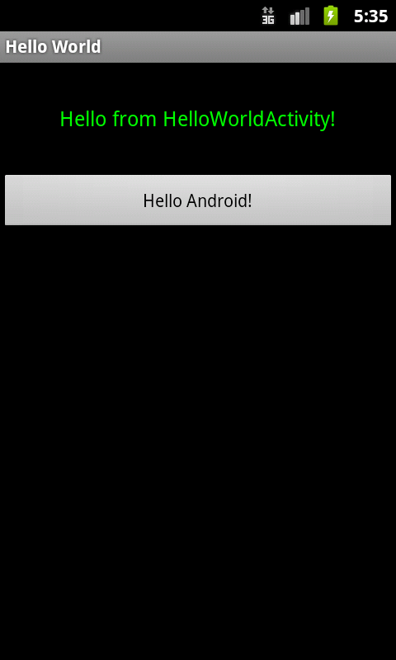

Note: It is not necessary to emulate the layout above exactly. If you get stuck trying to change the text color, use Google or simply leave the text with its original color.

1. Lastly, explore the AndroidManifest.xml file – this file declares the application features, required permissions, application name and icons, activities, and many other elements. This file can too be edited as XML using a simple text editor, or (preferably) using the rich interface:  
   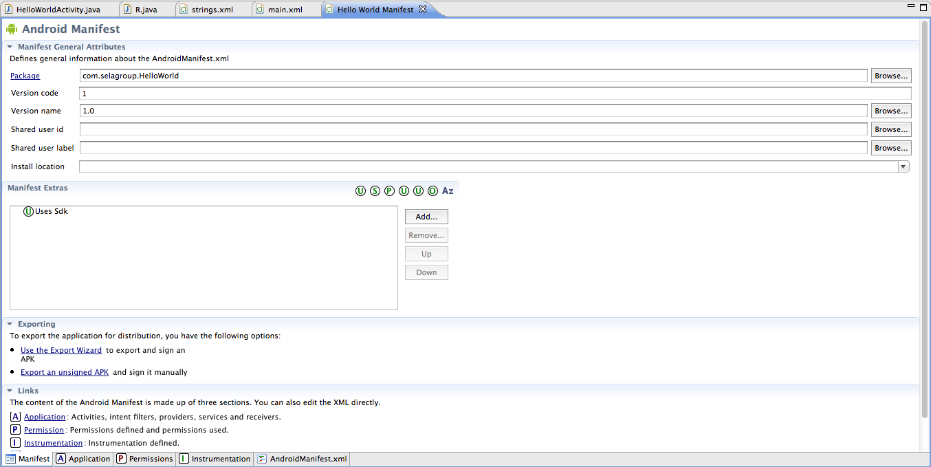  
   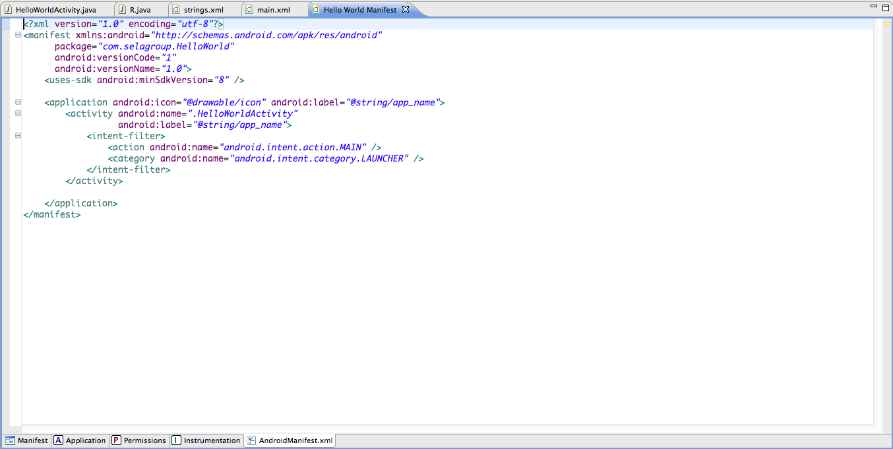
2. Run the application by clicking the **Run** button in the Eclipse toolbar, or the **Run** menu.
3. Make sure your application launches successfully in the emulator.